NEWS RELEASE
FOR IMMEDIATE RELASE

AMPAC FINE CHEMICALS Announces
Expansion of Their Executive Team

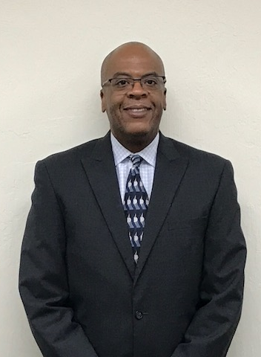 | 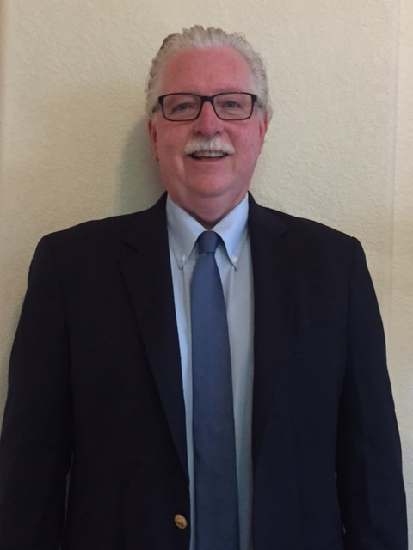
Steven Taylor | Christopher Conley
Rancho Cordova, CA, July 21, 2017 – AMPAC Fine Chemicals (AFC) is pleased to announce the addition of two new members to their executive team. Mr. Steven Taylor has joined as Vice President, Human Resources (HR) and Mr. Christopher (Chris) Conley as Vice President, Safety, Health and Environment (SH&E).

Steven Taylor brings over 22 years of US and international HR experience with major companies including Union Carbide, British Petroleum, General Electric, and most recently Honeywell International. Chris Conley joins AFC after a 35 year career with Aerojet Rocketdyne most recently serving as their Vice President for SH&E based at their Rancho Cordova, CA facilities.

“Steven will assume direct line accountability for all Human Resource professionals across the various AFC locations, positioning the HR function to ensure operational excellence in HR service to the business” states Dr. Aslam Malik, President and CEO, AFC. Steven holds a B.S. in Sociology and an M.S. in Labor & Industrial Relations from the University of Illinois.

“Chris brings extensive SH&E knowledge to AFC and will integrate comprehensive SH&E training and oversight across all our operations. He has a special familiarity with all aspects of our Rancho Cordova facilities and a vast experience with energetic chemistry” shares Dr. Malik. Chris has a M.S. in Environmental Health from East Tennessee State.

Both executives will be based at the AFC Headquarters in Rancho Cordova, CA.

ABOUT AMPAC FINE CHEMICALS LLC
AFC is a U.S.-based company with demonstrated capabilities in process development, scale-up, and cGMP-compliant commercial production of active pharmaceutical ingredients and registered intermediates for pharmaceutical and biotechnology customers. Its specially engineered facilities and experienced staff allow AFC to safely produce highly energetic compounds at commercial scale. In addition, AFC’s other technology platforms include production of highly potent compounds, continuous processes and industrial-scale chromatographic separation using simulated moving bed chromatography, and Analytical Services to the Pharmaceutical Industry. AFC’s operations are located in Rancho Cordova & El Dorado Hills CA, in La Porte, Texas and Petersburg, VA. Additional information about us can be obtained by visiting our web site at www.ampacfinechemicals.com.

Contact: Patrick Park +1 (916) 357-6376
Website: ampacfinechemicals.com
SOURCE: AMPAC Fine Chemicals (AFC)

